CS 543 Computer Vision MP1 Report

2/6/2013

YI CHENG

yicheng1

**Description**

In this MP, a set of solutions were implemented to align separated red, green, blue layers of images together. The solution uses the correlation (normxcorr2) between values or the gradients (edges) of each layer. In general, images with relatively balanced RGB values use the value correlations, and the gradient correlation can be adopted to align images with relative clear edges or features. The results are checked manually with necessary cropping.

**Results:**

All results are shown based on the red layer having displacement (0, 0)

* River: Green: (1,-4) Blue(-1,-9) obtained by both value and gradient correlation

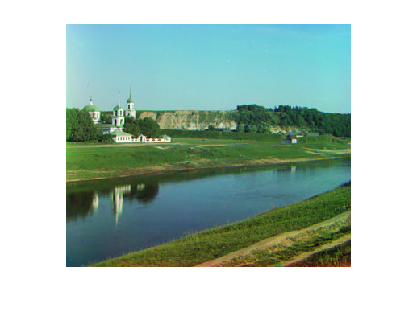

* 3-way: Green(-1,-9) Blue(-1,-13) obtained by both value and gradient correlation

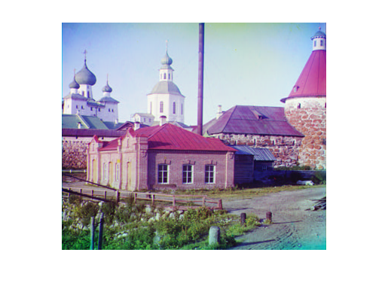

* Railway: Green(-1,-6) Blue(-4,-11) obtained only by value correlation

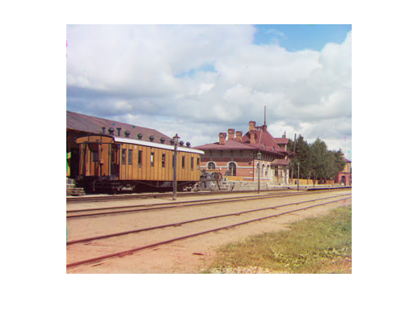

* Temple: Green(-1,-5), Blue(-1,-5) obtained only by gradient correlation

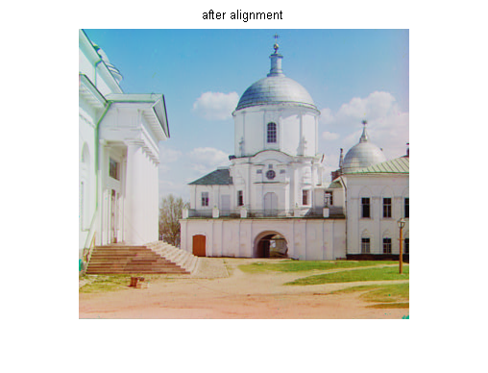

* Sitting man: Green(-2,-7) Blue(-4,-11) obtained only by gradient correlation

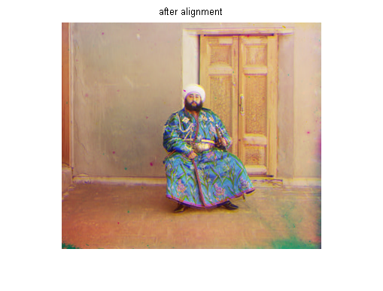

* Frame: Green(0,-5) Blue(-2,-9) obtained only by value correlation 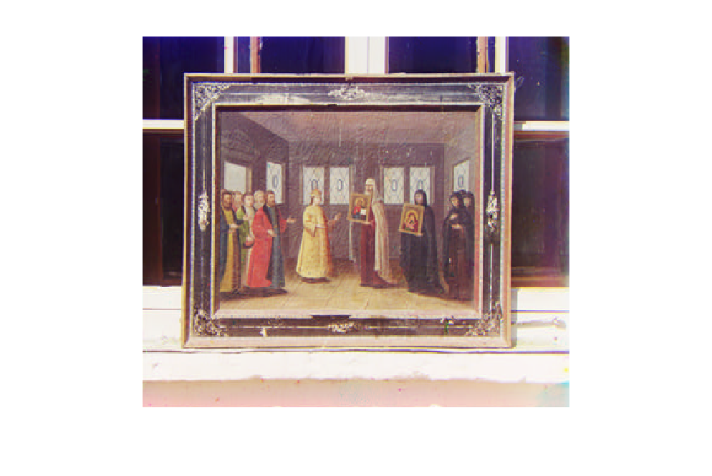

**Extra credit part:**

For large images, checking normxcorr2 becomes impractical since the run time is O(n2) in terms of the size of dimensions. A sampling method is adopted as follows: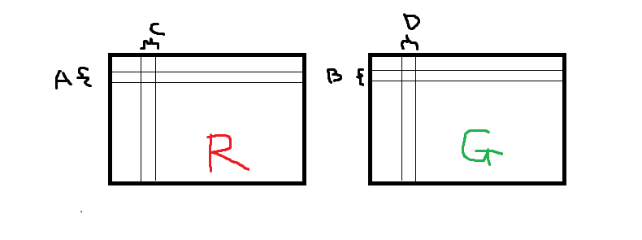

Suppose red and green layers are off by a small amount, we first sample a horizontal stripe A of Red and B of Green where A and B cover about the same region. Since A and B are long stripes, normxcorr2 will give a very good result in terms of horizontal displacement, but not vertical displacement. However, similar method can be used vertically with C and D to find out the vertical displacement accurately. With the property width(A) >> height(A) & width(B) >> height(B) and the reverse for C and D, the complexity of normxcorr2 between A and B is linear with the width of the picture, and that between C and D is linear with the height, so the total computation time for large images remain linear. In this case, the program finishes in about 15 seconds on a 3700x3200 image with sampling methods.

One tricky part is that the stripes need to be carefully selected. For example, A and B cannot contain mostly horizontal lines, otherwise the correlation will show multiple possibilities of displacement. Similarly, C and D cannot contain mostly vertical lines.

For further improvement, in order to automate the process, multiple stripes can be sampled at the same time, and pick the mean of all the calculated displacement values.

**Results:**

All results are shown based on the red layer having displacement (0, 0)

* Old man: Green(-24,-77), Blue(-149,-62)

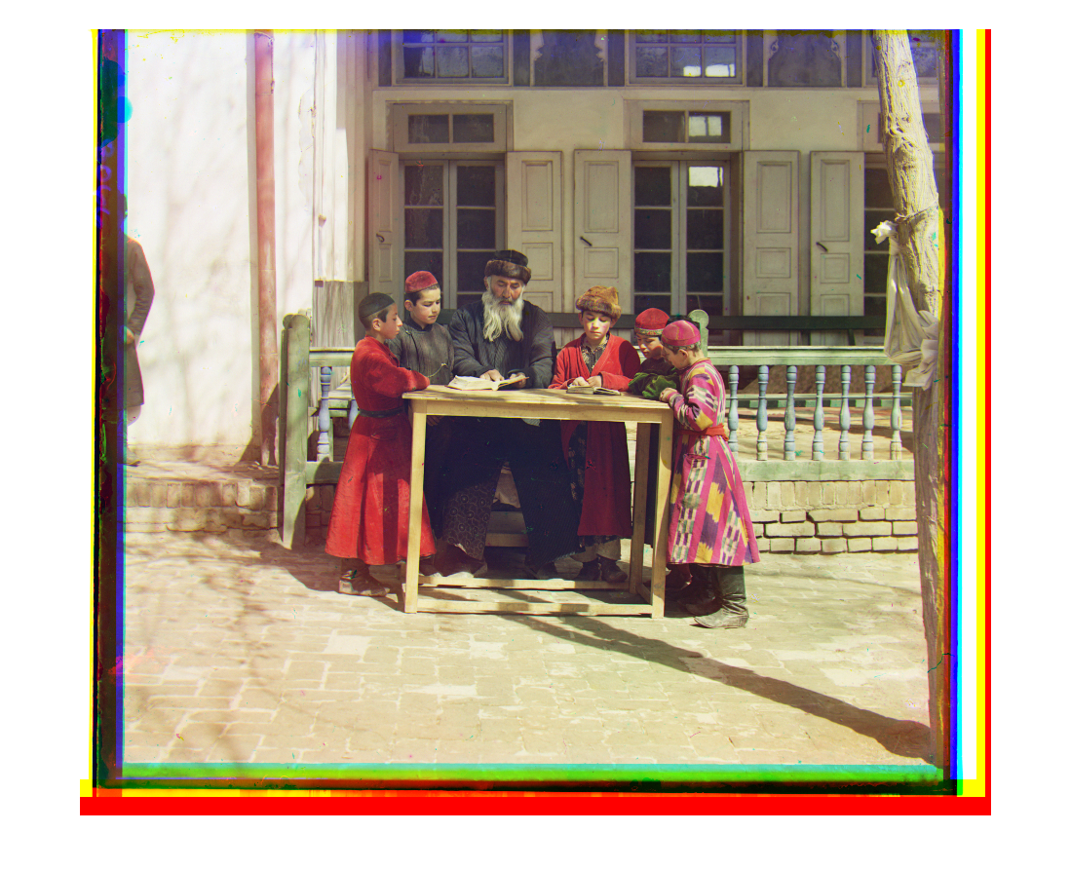

* Lady: Green(-8,-59) Blue(-5,-117)

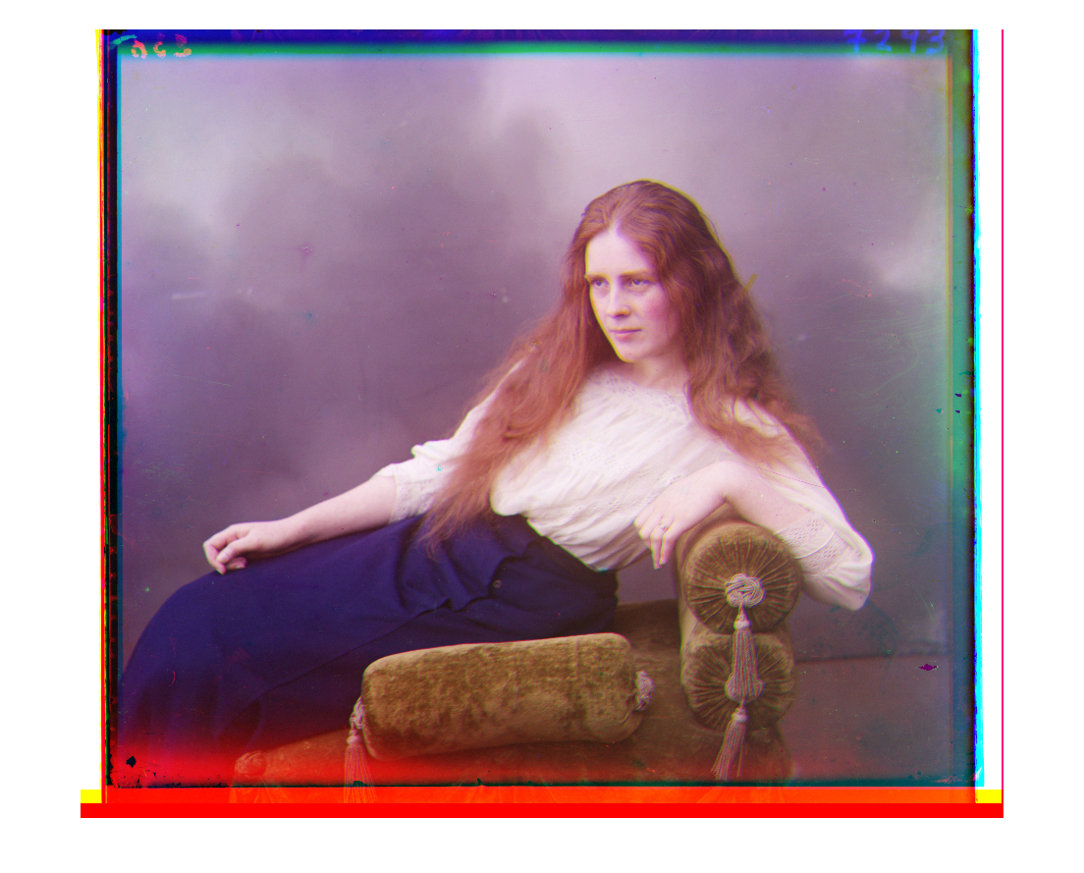

* Table: Green(-12,-49) Blue(-33, -72)

